
RS/E
Linkage-less Power Burner

Project | Project Name | Click here to enter text. |   UL295/ UL 296  The RS/E series has been designed for use in low or medium temperature hot water boilers, steam boilers, diathermic oil boilers, warm air appliance, and similar applications.  Operation can be “two stage progressive” or, alternatively, “modulating” with the installation of a PID logic regulator and respective probes. RS/E series burners guarantee high- efficiency, reducing fuel and running costs while the exclusive design provides simple use and maintenance with low sound emissions.
Project | Site Location
Project | Installation Altitude
Project | Engineering Firm
Project | Installing Contractor
Project | Riello Representative
Project | Rep. Contact Information
Project | RBNA Project Number
Project | Job Name
Project | Equipment Manufacturer
Project | Equipment Model
Project | Equipment Type
Project | Input
Project | Fuel Type
Project | Chamber Length
Project | Chamber Width
Project | Chamber Height / Diameter
Project | Chamber Pressure
Project Notes:

General Burner Data | RS 28 | 120V/1Ph/60Hz
General Burner Data | RS 38 | 120V/1Ph/60Hz
General Burner Data | RS 50 | 120V/1Ph/60Hz
General Burner Data | RS 70 | 208-230V/3Ph/60Hz
General Burner Data | RS 70 | 460V/3Ph/60Hz
General Burner Data | RS 70 | 575V/3Ph/60Hz
General Burner Data | RS 100 | 208-230V/3Ph/60Hz
General Burner Data | RS 100 | 460V/3Ph/60Hz
General Burner Data | RS 100 | 575V/3Ph/60Hz
General Burner Data | RS 130 | 208-230V/3Ph/60Hz
 | RS 130 | 460V/3Ph/60Hz
 | RS 130 | 575V/3Ph/60Hz
 | RS 190 | 208-230V/3Ph/60Hz
 | RS 190 | 460V/3Ph/60Hz
 | RS 190 | 575V/3Ph/60Hz

Optional Accessories | RWF 55 PID Modulating Control | X
Optional Accessories | Air Intake Adaptor
Optional Accessories | Propane Conversion Kit
Optional Accessories | Alarm Horn with Silence Switch | X
Optional Accessories | Local/ Remote control Switch | X
Optional Accessories | Additional Indicating Light
Optional Accessories | 3 Dry Contact Relays | X
Optional Accessories | Combustion Head Extension
Optional Accessories | Pre-Wire and Assembled Gas Train
Optional Accessories | UV Scanner | X
Optional Accessories | Temperature Sensor
Optional Accessories | Pressure Sensor
Optional Accessories | 4.3” HMI
Optional Accessories | Control Circuit Transformer

Standard Feature

- Siemens LMV37 microprocessor flame safeguard
- UV scanner flame detection
- Premium efficiency motor
- Aluminum combustion air fan
- Die cast aluminum mono-bloc construction
- Air suction circuit lined with sound-proofing material
- Fan with reverse curve blades
- Fully independent air and fuel actuators featuring air damper for air setting and butterfly valve for regulating fuel
- Combustion head that can be set based on the required output
- High gas pressure switch to stop the burner in the case of excess pressure on the fuel supply line
- Low air pressure switch stops the burner in case of insufficient air quantity at the combustion head
- Post-ventilation through parameter setting
- Burner on/off switch
- Flame inspection window
- Manual or automatic output increase/decrease switch
- Slide bars for easier installation and maintenance
- NEMA 1 electric protection level. - Single point 3 ph power connection with optional Control Circuit Transformer Installed
- 5 indicator lights, Power ON, Main Fuel ON, Call for Heat, Ignition, Flame failure.
- 1 three-way switch: off/local/remote
- 1 Alarm Horn
- 1 Alarm silence push-button
- 3 dry contact relays

Output Capacity Chart
RS 28, 38, 50/E(-EV)
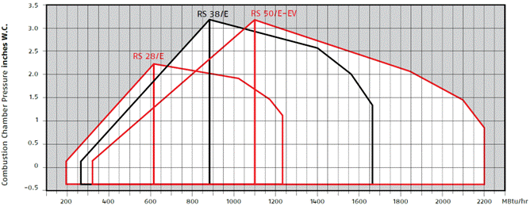
RS 70, 100, 130, 190/E-EV
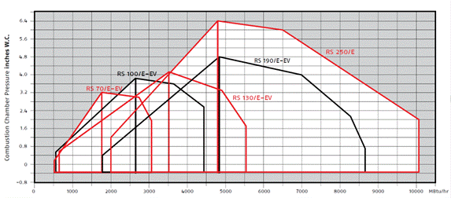
Max. firing rates are based on zero furnace backpressure, ambient temperature of 68 °F, barometric pressure 394 inches WC, 329 ft. elevation a.s.l. For more details and final burner selection refer to applicable installation manual.

Boiler Data Chart
 |  |  | RS28/E | RS38/E | RS50/E-EV | RS70/E-EV | RS100/E-EV | RS130/E-EV | RS190/E-EV
 |  |  | General Data
Burner operation |  |  | Progressive 2 stage or low-high-low / full modulation with supply of modulating signal
Servomotor | Make & Model |  | Siemens SQM33
Fire Input Range (min / max) |  | MBtu/Hr | 198- 1232 | 266 - 1666 | 321 - 2201 | 512 – 3084 | 570 – 4405 | 607-5545 | 1781-8673
Working temperature range | min / max | ^{O}C | 0-40
Working temperature range | min / max | ^{O}F | 32-104
Combustion air fan type |  |  | Centrifugal with reverse incline blades |  |  |  |  |  | Centrifugal
Combustion air temperature | max. | ^{O}C | 60
Combustion air temperature | max. | ^{O}F | 140
Approvals |  |  | cULus (UL795, CSA 3.4) CSD-1 Compliant
 |  |  | Fuel Data
Fuel heating value | Natural gas | Btu/ft³ | 1000
Specific gravity | Natural gas |  | 0.64
 |  |  | Electrical Data
Main voltage | volts / phase / hertz |  | 120V/1PH/60HZ |  |  | 230V-460V-575V /3PH/60HZ
Control voltage | volts / phase / hertz |  | 120/1/60  Separate control voltage supply required on 3 phase versions unless integral control transformer is installed (optional)
Fan motor size | HP |  | 0.5 |  | 0.75 | 1.5 | 3 | 3 | 7.5
Amperage draw | Motor | Amps | 5.2 |  | 9.8 – 4.9 | 4.3 – 2.0 – 1.6 | 8.1 – 3.9 – 3.0 | 8.1 – 3.9 – 3.0 | 17.8 – 8.9 - 7.1
FLA |  |  |  |  |  |  | 10-4.8-3.9
MCA |  |  |  |  |  |  | 12-6-5
MOCP |  |  |  |  |  |  | 15-10-5
Motor type |  |  | TEFC
Ignition transformer(s) |  | GAS | 120V-1.6A / 1x8kV-20mA
Flame safeguard | Riello | Model | Siemens LMV37
Burner protection level |  | NEMA | 1
Operation |  |  | Intermittent (1 stop minimum every 24hr of continuous operation)
 |  |  | Emissions
Sound level |  | dBa | 68 | 70 | 72 | 75 | 77 | 78.5 | 83.1
CO₂ operating range |  | % | 9 – 10.5%
CO emission (@ 3.0% O₂) |  | ppm | <25
NO₂ emission (NO_{X} prompt) (@ 3.0% O₂) |  | ppm | <65
All emission values are based on laboratory conditions and are for reference only. Emissions testing conducted on European DIN combustion test chambers.
Maximum input ratings based on furnace pressure of 0"w.c. Contact factory if required input is outside of that shown in operating charts located in the burner manuals.
Reference conditions: Ambient temperature 68^{O}F (20^{O}C). Barometric pressure 394"w.c. Altitude <2000 fasl. Contact factory for higher altitude selection.

General Dimensions & Weight
Burner Dimensions
Model | A | B | C | D | E | F | H
RS 28/E | 26" | - | - | 20-1/4" | 26-3/4" | 8-1/2" | 5-1/2"
RS 38/E | 26" | - | - | 20-1/4" | 26-3/4" | 8-1/2" | 5-1/2"
RS 50/E-EV | 26" | - | - | 20-1/4" | 26-3/4" | 8-1/2" | 6”
RS 70/E-EV | 33-1/2” | 16-3/4" | 16-3/4" | 25-1/4” | 40-3/4" | 9-9/16” | 7-1/16"
RS 100/E-EV | 33-1/2” | 16-3/4" | 16-3/4" | 25-1/4” | 40-3/4" | 9-9/16” | 7-1/16"
RS 130/E-EV | 33-1/2” | 16-3/4" | 16-3/4" | 25-1/4” | 40-3/4" | 10-3/4” | 7-1/2"
RS 190/E-EV | 33-7/8” | 16-3/4" | 16-3/4" | 25-11/16” | 40-3/4" | 14-11/16” | 8-3/4"
 | I | L | M | N | O | V | P | Q
RS 28/E | 13-15/16" | 6-7/16" | 1-1/2" | 4-1/4" | 37-1/4" | 6-5/8" | - | -
RS 38/E | 13-15/16" | 6-7/16" | 1-1/2” | 4-1/4" | 37-1/4" | 6-5/8" | - | -
RS 50/E-EV | 13-15/16" | 6-7/16" | 1-1/2” | 4-1/4" | 37-1/4" | 6-5/8" | - | -
RS 70/E-EV | 16-3/4” | 8-13/16" | 2" | 5-11/16" | 52-13/16” | 8-3/4" | 11-1/4” | 10-7/8”
RS 100/E-EV | 16-3/4 | 8-13/16" | 2" | 5-11/16" | 52-13/16” | 8-3/4" | 12-13/16" | 10-7/8”
RS 130/E-EV | 16-3/4 | 8-13/16" | 2" | 5-11/16" | 52-13/16” | 8-3/4" | 12-13/16" | 10-7/8”
RS 190/E-EV | 17-3/16" | 9-1/16” | 2" | 5-15/16" | 63-1/4” | 8-3/4" | 16-3/4” | 12-1/16"

RS 70-100-130-190/E-EV
RS 28/E-38/E-50/E-EV
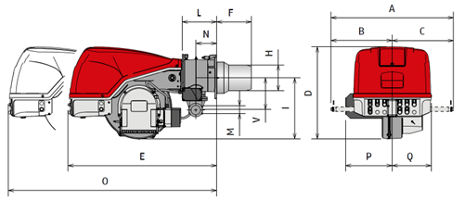
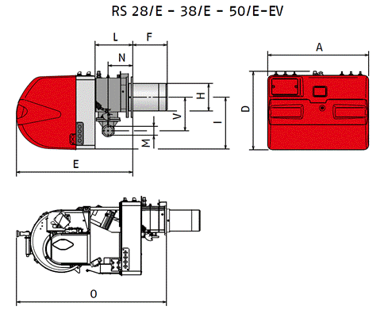

Mounting Plate Details
Model | A | B | C
RS 28/E | 6-5/16" | 8-13/16" | 3/8”W
RS 38/E | 6-5/16" | 8-13/16" | 3/8”W
RS 50/E-EV | 6-5/16" | 8-13/16" | 3/8”W
RS 70/E-EV | 9-1/6" | 12-13/16” – 14-1/2" | 5/8”W
RS 100/E-EV | 9-1/6" | 12-13/16” – 14-1/2" | 5/8”W
RS 130/E-EV | 9-1/6" | 12-13/16” – 14-1/2" | 5/8”W
RS 190/E-EV | 9-1/6" | 12-13/16” – 14-1/2" | 5/8”W

Package Size
Model | Dimensions - inches |  |  | Weight
Model | A | B | C | lbs
RS 28/E | 47-1/4" | 23-5/8" | 28" | 143
RS 38/E | 47-1/4" | 23-5/8" | 28" | 150
RS 50/E-EV | 47-1/4" | 23-5/8" | 28" | 154
RS 70/E-EV | 59-1/16" | 33-1/2" | 39-3/8" | 183
RS 100/E-EV | 59-1/16" | 33-1/2" | 39-3/8" | 188
RS 130/E-EV | 59-1/16" | 33-1/2" | 39-3/8" | 201
RS 190/E-EV | 59-1/16" | 33-1/2" | 39-3/8" | 231

Flame Safeguard
Model |  | LMV37
Electrical Supply | V/Ph/Hz | 120/3/50-60
Primary fuse | A | 6
Ambient Conditions | %RH | 95  (no condensation)
Ambient Conditions | °F | -4-140
Flame Detection | Type | UV
Approval |  | cURus
The Siemens LMV37 flame safeguard control is a microprocessor based parallel positioning system

Gas Train

CSD-1 and UL compliance Gas Train SEE PROJECT DOCUMENTS FOR SPECIFIC GASTRAIN DRAWING

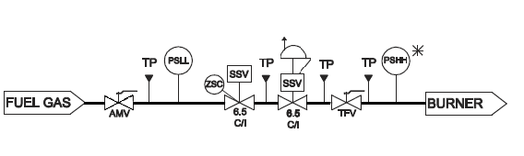
*USA installation excluding Massachusetts

OR

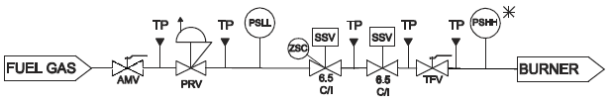

RIELLO NORTH AMERICA
Corporate Headquarters
2165 Meadowpine Blvd
Mississauga, ON L5N 6H6, Canada

USA OFFICE

35 Pond Park Rd.
Hingham, MA02043, USA

Phone: 905-542-0303
Fax: 905-542-1525

